**Ideation Phase**

**Empathy Map Canvas**

|  |  |
| --- | --- |
| Date | 27-06-2025 |
| Team ID | LTVIP2025TMID46688 |
| Project Name | DocSpot |
| Maximum Marks | 4 Marks |

**Empathy Map Canvas:**

The Empathy Map Canvas helps us understand the users of **DocSpot**, our healthcare appointment booking platform, from a human-centered perspective. It focuses on the thoughts, feelings, actions, and experiences of users—mainly patients—who struggle with the current manual or inefficient booking systems. By exploring what users see, say, think, and feel, we gain valuable insights into their pain points and expectations. This understanding guides us in building a solution that truly addresses their real-world problems and delivers a smooth, reliable healthcare experience.

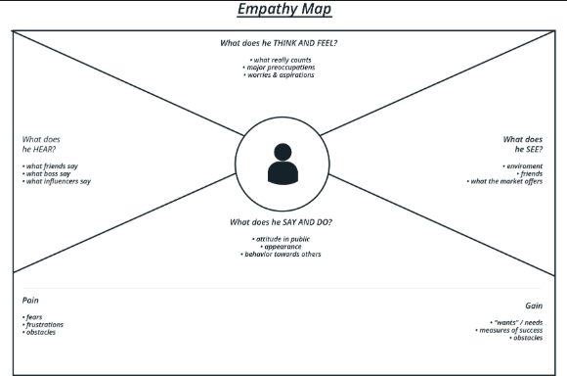

**Empathy Map Canvas – Target User: Patient**

**SAYS**

* “I want a doctor who’s available when I need.”
* “I don’t know which doctor is best for my issue.”
* “Why is booking an appointment so confusing?”

**THINKS**

* “Will I get a slot today?”
* “What if the doctor isn’t available when I reach?”
* “Is this clinic reliable? Should I go to another one?”

**DOES**

* Searches for doctors online or through friends
* Waits in line at hospitals to get an appointment
* Tries calling hospitals but gets no response

**FEELS**

* Frustrated during emergencies or delays
* Confused by lack of clear info on doctor timings
* Helpless when appointments get cancelled or delayed

**Insights Gained**

From this empathy map, we understood the **emotional and practical struggles** faced by patients. The key takeaways were:

* Need for real-time doctor availability
* Need for verified doctor profiles and clarity
* Need for a simple, online system to reduce anxiety and waiting

This canvas guided the design of **DocSpot** to ensure our platform meets real user needs in a user-friendly and stress-free way.